**Faculty of Engineering and Architecture**

**Department of Electrical and Computer Engineering**



**EECE 310L**

**Lab 4 _ RC and RLC circuits**

**Name: Emilie Akiki**

**ID: 201100328**

**Email:** [**eya03@aub.edu.lb**](mailto:eya03@aub.edu.lb)

**Section 5**

**Group 1**

**November 5, 2011**

**Table of contents: page**

List of figures……………………………………………………….…..3

Objectives………………………………………………………………4

Lab Equipment used……………………………………………………5

Lab tools used……………………………………………………….…. 5

Components used…………………………………………………….…5

Experimental Procedure and Discussion……………………………….6

References…………………………………………………………......28

Mistakes and Problems faced in the lab…………………………….....29

Signed statement……………………………………………………....30

**List of figures and tables:**

***Tables:***

* Table showing percentage of error in the resistors used (page 5)
* Measurements of phase angle using Y-T method (page 7)
* Measurements of phase angle using Lissajous method (page 8)
* Comparison different measurements of Vout in a lag network (page14)
* Comparison different measurements of Vout in a lead network (page 19)
* Set 1 of measurements in RLC circuit (page 22)
* Set 2 of measurements in RLC circuit (page 22)
* Set 3 of measurements in RLC circuit (page 23)
* Magnitude of transfer function of set1 (page 23)
* Magnitude of transfer function of set2 (page24)
* Magnitude of transfer function of set3 (page24)
* Resonance frequency and bandwidth of set 1, set 2 and set 3 (page 26)

***Figures:***

* RC circuit to measure phase angle (page 6)
* How to measure ∆T on the oscilloscope (page 7)
* How to measure period T on the oscilloscope (page 7)
* Lissajous figure (page 8)
* Lag network (page 10)
* 100 Hz sine wave lag (page 11)
* 10 kHz sine wave lag (page 12)
* 10 kHz sine wave lag (page 12)
* 100 Hz square wave lag (page 13)
* 1 kHz square wave lag (page 13)
* 10 kHz square wave lag (page 14)
* Lead network (page 15)
* 10 kHz sine wave lead (page 16)
* 1 kHz sine wave lead (page 17)
* 100 Hz sine wave lead (page 17)
* 10 kHz square wave lead (page 18)
* 1 kHz square wave lead (page 18)
* 100 Hz square wave lead (page 19)
* RLC circuit (page 21)
* Plot of set 1 (page 25)
* Plot of set 2 (page 25)
* Plot of set 3 (page 26)

**Objectives:**

The objectives of this experiment were to observe the response of an RC circuit in both frequency and time domains. We observed also the frequency response of an RLC circuit. We used the oscilloscope to measure the needed parameters such as phase angle (using two methods) and corresponding output voltages.

**Lab equipments used:**

The equipments that we used are mainly:

* The function generator
* The oscilloscope
* The digital multimeter (DMM)
* A breadboard

**Lab tools used:**

From the toolbox that we have, we only needed:

* the wire stripper
* the wire cutter

**Lab components used:**

We used:

* several resistors of different values
* several capacitors
* several inductors
* connection wires

|  |  |  |
| --- | --- | --- |
| Theoretical value | Measured value | % error |
| 56 Ω | 55.92 Ω | 0.143% |
| 100 Ω | 99.89 Ω | 0.11% |
| 1 kΩ | 0.99 kΩ | 1% |
| 20 kΩ | 19.57 kΩ | 2.15% |

**Experimental procedure and discussions:**

1. ***Phase shift measurements***

*A1.Circuit diagram:*

**

*A2. Detailed experimental procedure:*

**Measurements settings:**

In this part of the experiment, we designed an RC circuit on the breadboard. The values chosen for equipments were 20 kΩ for the resistor and 1 nF for the capacitor. After connecting the frequency generator properly, we provided a signal of frequency 5 kHz and 6V peak to peak. We connected channel 1 of the oscilloscope to the branch BA where we have the resistor and channel 2 to the branch DB where we have the capacitor.

In order to measure the phase shift experimentally, we are going to refer to two distinct methods:

* The first method consists of measuring time difference ΔT between the 2 signals (using Y-T mode of the oscilloscope) and then derive the phase difference from it. In this method the phase angle φ= (ΔT/T)*360 and we will get the result in degrees, or φ= (ΔT/T)*2π to get the result in radians.
* The second method is called the Lissajous method. It consists of measuring 2 parameters A and B from the ellipse shown on the oscilloscope (using X-Y mode). In this method the phase angle φ= sin-1(B/A)

**Assumptions:**

In this experiment the resistor used has 2.15% of error. Not to forget that wires have internal resistances. This fact is not taken into consideration during the theoretical computations.

*A3. Measurements and results:*

**Theoretical calculations:**

First we measured the theoretical phase shift of the circuit given. The formulas used are:

Tan φ= Xc/R with Xc=1/(ωC) =1/ (2πfC)

For a given f= 5 kHz, R= 20 kΩ and C= 1nF

Xc= 1/(2π*5*103*1*10-9)= 31830.99

Tan φ= 31830.99/20000=1.59

= > φ= tan-11.59= 57.858o

**Experimental results:**

* Method 1: Y-T format Δ

|  |  |  |
| --- | --- | --- |
| ΔT (s) | T (s) | Φ (degrees) |
| 0.00003 | 0.0002 | 54 |

To measure ΔT we adjust the 2 probes obtained on the oscilloscope screen to have them superposed and aligned on the same horizontal axis. This can be done by modifying VOLT/DIV and SEC/DIV settings. Now ΔT can be clearly deduced from the difference between 2 points selected as shown:

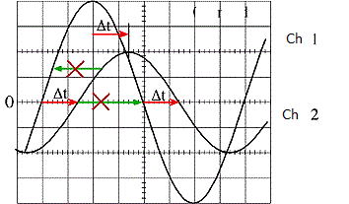

T is the period of a signal. In this case, both signals have same T. we measure it on the oscilloscope as shown in the figure below. Note that we can obtain T if we already know the frequency by simply using the formula: T= 1/F

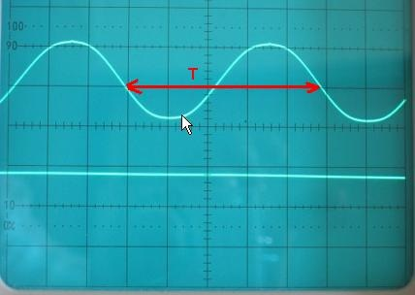

Now φ is calculated using the formula mentioned before:

φ= (ΔT/T)*360 = (0.00003/0.0002)*360= 54o

* Method 2: Lissajous figure

|  |  |  |
| --- | --- | --- |
| 2B | 2A | Φ (degrees) |
| 5 | 6.1 | 55.05 |

As we explained earlier, this method consists of finding 2 essential parameters A and B in order to determine the phase angle. But first we should modify the oscilloscope to have X-Y mode, leaving the connections same as before. We observe an ellipse on the oscilloscope screen. We should center the ellipse symmetrically. This is done by adjusting the VOLTS/DIV controls of X and Y and using the vertical and horizontal POSITION knobs.

The values of A and B should be deduced from the ellipse as shown in the figure:



Now φ is calculated using the corresponding formula for this method:

φ= sin-1(B/A)= sin-1(5/6.1)= 55.05o

**Comparison and %error:**

The theoretical value for this experiment is: 57.858o

The experimental value obtained using the first method is: 54o

The experimental value obtained using the second method is: 55.05o

We can clearly see that, using the second method (Lissajous figure) we obtained the closest value to the theoretical. But we still can see a difference between them.

In method 1, the percentage of error is: [(57.858-54)/57.858] *100 = 6.668%

In method 2, the percentage of error is: [(57.858-55.05)/57.858] *100= 4.853%

*A4. Discussions:*

**1.**For the ellipse to look as a full circle, we should have A=B which implies also that the phase angle should be = sin-1(1) = + - 90o. This occurs at very low frequencies.

**2.**When the ellipse looks like a straight line, this means that Vout= Vin. This equality implies that the capacitor is acting as a short circuit. This happens only at very high frequencies.

1. ***Lead and lag networks***

***Lag network:***

*B1. Circuit diagram:*



*B2. Detailed experimental procedure:*

**Measurements settings:**

For the lag network, we formed an RC circuit on the breadboard. We selected a 1 kΩ resistor and 0.1 uF for the capacitor. We provide a sinusoidal signal of amplitude 1 V. The frequency of the input signal is initially fixed to 100 Hz. We will vary it later to observe the changes. We select a channel of the oscilloscope and connect it to the output which is across the capacitor. The other one is connected to the input signal.

The other part of this experiment consists only of changing the input to a square wave of amplitude 1V. The frequency is varied same as in the sinusoidal wave part.

**Assumptions:**

In this experiment the resistor used has 1% of error. Not to forget that wires have internal resistances. This fact is not taken into consideration during the theoretical computations.

*B3. Measurements and results:*

**Theoretical calculations:**

The transfer function corresponding to this lag network is:

 (Vc is Vout and VSRC is Vin )

The magnitude of the transfer function is:



This means that Vout (peak to peak)= Vin *(1/ √1+ω2C2R2)

We can replace ω by 2πf.

* Sinusoidal wave input:

For Vin= 1 V, R=1kΩ, C=0.1uf and f= 100Hz, Vout= 1*(1/√(2π*100)2(0.1*10-6)2(1*103)2) = 998.03mV

For Vin= 1 V, R=1kΩ, C=0.1uf and f= 1kHz, Vout= 1*(1/√(2π*1000)2(0.1*10-6)2(1*103)2) = 846.73mV

For Vin= 1 V, R=1kΩ, C=0.1uf and f= 10 kHz, Vout= 1*(1/√(2π*10000)2(0.1*10-6)2(1*103)2) = 157.18 mV

* Square wave input:

For the square wave input, we have the same calculated values as the sinusoidal wave. This is because we have the same transfer function independently of the signal nature.

**Experimental results:**

* Sinusoidal wave:

For f = 100 Hz, we obtained 2 overlapping graphs of Vout andVin as shown in the figure.

The value of Vout as read on the oscilloscope is = 1000 mV

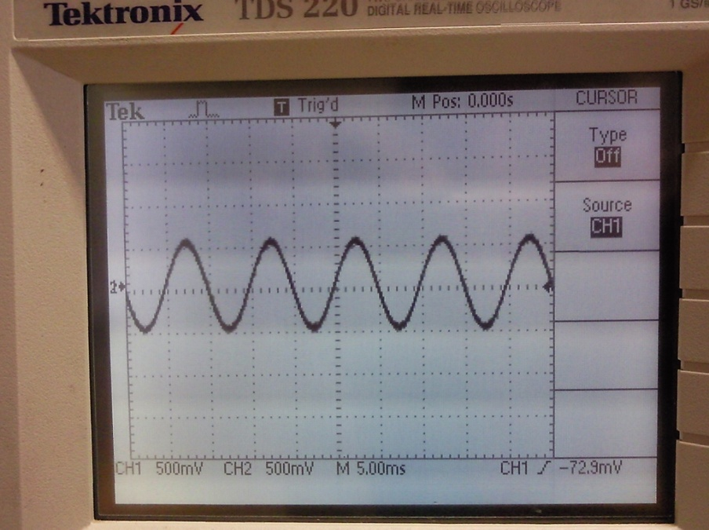

For f = 1 kHz, we obtained 2 distinct graphs of Vout andVin as shown in the figure. We can notice that Vout lags Vin.

The value of Vout as read on the oscilloscope is = 920 mV

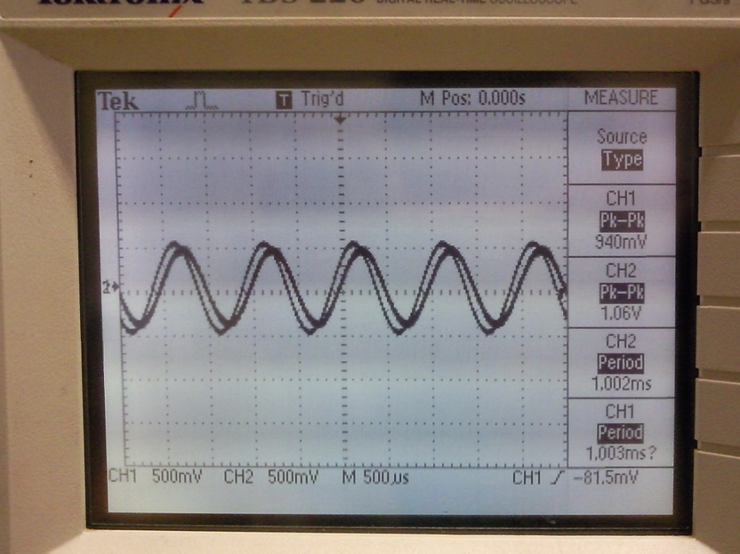

For f = 10 kHz, we obtained 2 distinct graphs of Vout andVin as shown in the figure. We can notice that Vout clearly lags Vin in this case.

The value of Vout as read on the oscilloscope is = 228 mV

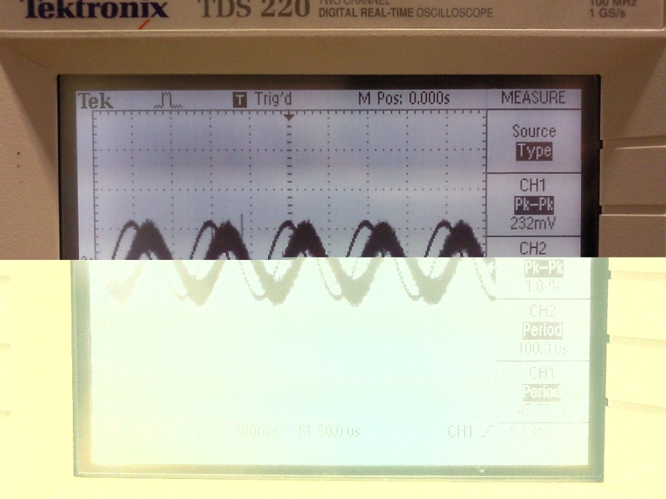

* Square wave:

For f = 100 Hz, we obtained 2 overlapping graphs of Vout andVin as shown in the figure.

The value of Vout as read on the oscilloscope is = 1000 mV

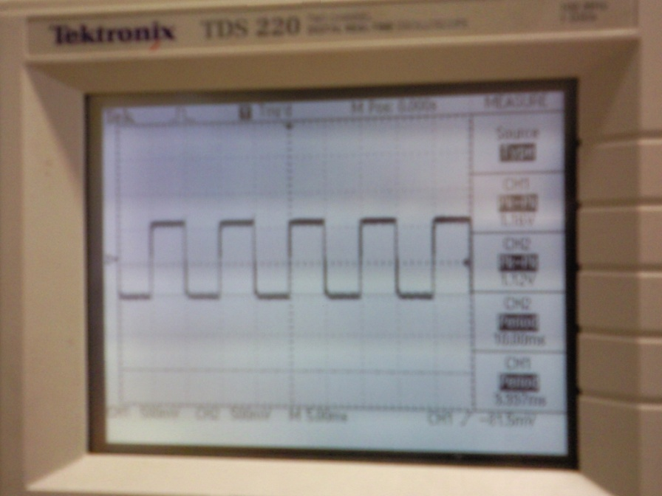

For f = 1 kHz, we obtained 2 distinct graphs of Vout andVin as shown in the figure. We can notice the difference between the 2 graphs. The shape of the output differs from the input. This is due to the fact that the circuit is a low pass filter and the square wave has its high frequencies on the edges (Fourier). Therefore we have distortion.

The value of Vout as read on the oscilloscope is = 1000 mV

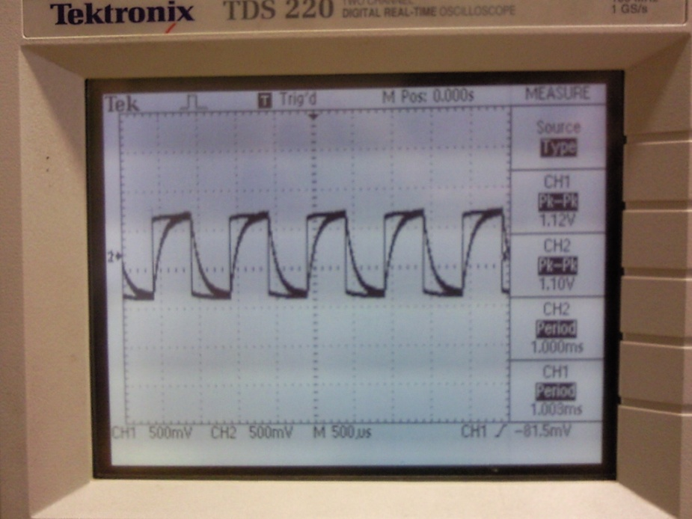

For f = 10 kHz, we obtained 2 distinct graphs of Vout andVin as shown in the figure. At this frequency, which is considered high, the output appeared as a triangular wave. This is because, when we have high frequencies, capacitor becomes a short circuit and the RC circuit acts as an integrator.

The value of Vout as read on the oscilloscope is 356mV

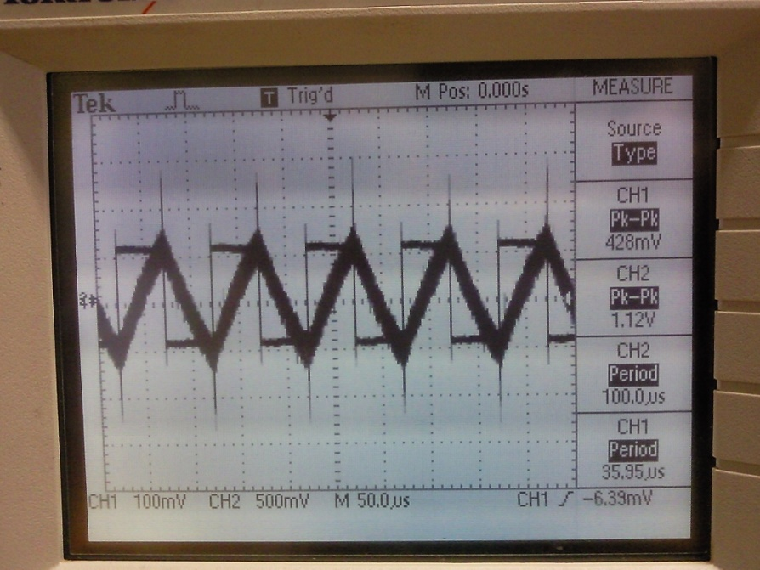

**Comparison and % of error:**

|  |  |  |  |
| --- | --- | --- | --- |
| Frequency | Theoretical value of Vout | Vout for Sine wave input | Vout for Square wave input |
| 100 Hz | 998.03 mV | 1000 mV | 1000 mV |
| 1 kHz | 846.73 mV | 920 mV | 1000 mV |
| 10 kHz | 157.18 mV | 228 mV | 356 mV |

The values measured experimentally for a sine wave input were the closest to the theoretical values.

* Sinusoidal wave:

For f= 100 Hz, %error= 0.197%

For f= 1 kHz, % error= 8.65%

For f = 10 kHz, % error= 45.06%

* Square wave:

For f= 100 Hz, %error= 0.197%

For f= 1 kHz, % error= 18.1%

For f = 10 kHz, % error= 126.49%

***Lead network:***

*B1. Circuit diagram:*



*B2. Detailed experimental procedure:*

**Measurements settings:**

For the lead network, we formed an RC circuit on the breadboard. We selected a 1 kΩ resistor and 0.1 uF for the capacitor. We provide a sinusoidal signal of amplitude 1 V. The frequency of the input signal is initially fixed to 10 kHz. We will vary it later to observe the changes. We select a channel of the oscilloscope and connect it to the output which is across the resistor. The other one is connected to the input signal.

The other part of this experiment consists only of changing the input to a square wave of amplitude 1V. The frequency is varied same as in the sinusoidal wave part.

**Assumptions:**

In this experiment the resistor used has 1% of error. Not to forget that wires have internal resistances. This fact is not taken into consideration during the theoretical computations.

*B3. Measurements and results:*

**Theoretical calculations:**

The transfer function corresponding to this lag network is:

 (Vc is Vout and VSRC is Vin )

The magnitude of the transfer function is:



This means that Vout (peak to peak)= Vin *( ωCR / √1+ω2C2R2)

We can replace ω by 2πf.

* Sinusoidal wave input:

For Vin= 1 V, R=1kΩ, C=0.1uf and f= 10 kHz,

Vout=1* (2π*10000)(0.1*10-6)(1*103)/√(2π*10000)2(0.1*10-6)2(1*103)2) = 987.57 mV

For Vin= 1 V, R=1kΩ, C=0.1uf and f= 1 kHz,

Vout=1* (2π*1000)(0.1*10-6)(1*103)/√(2π*1000)2(0.1*10-6)2(1*103)2) = 532.02 mV

For Vin= 1 V, R=1kΩ, C=0.1uf and f= 100 Hz,

Vout=1* (2π*100)(0.1*10-6)(1*103)/√(2π*100)2(0.1*10-6)2(1*103)2) = 62 mV

* Square wave input:

For the square wave input, we have the same calculated values as the sinusoidal wave. This is because we have the same transfer function independently of the signal nature.

**Experimental results:**

* Sinusoidal wave:

For f = 10 kHz, we obtained 2 overlapping graphs of Vout andVin as shown in the figure.

The value of Vout as read on the oscilloscope is = 1000 mV

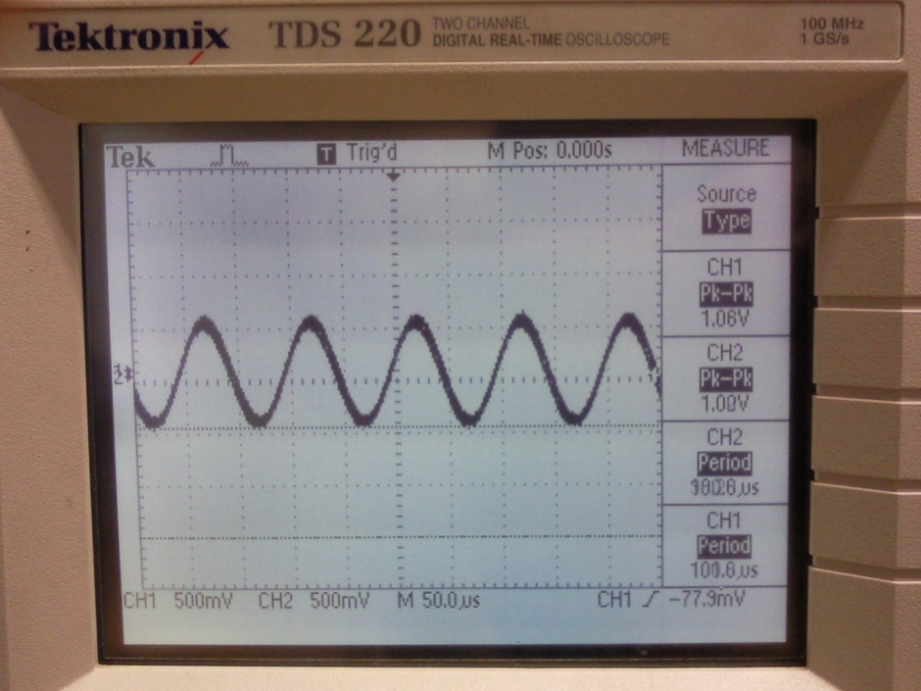

For f = 1 kHz, we obtained 2 distinct graphs of Vout andVin as shown in the figure. We can notice that Vout lags Vin.

The value of Vout as read on the oscilloscope is = 552 mV

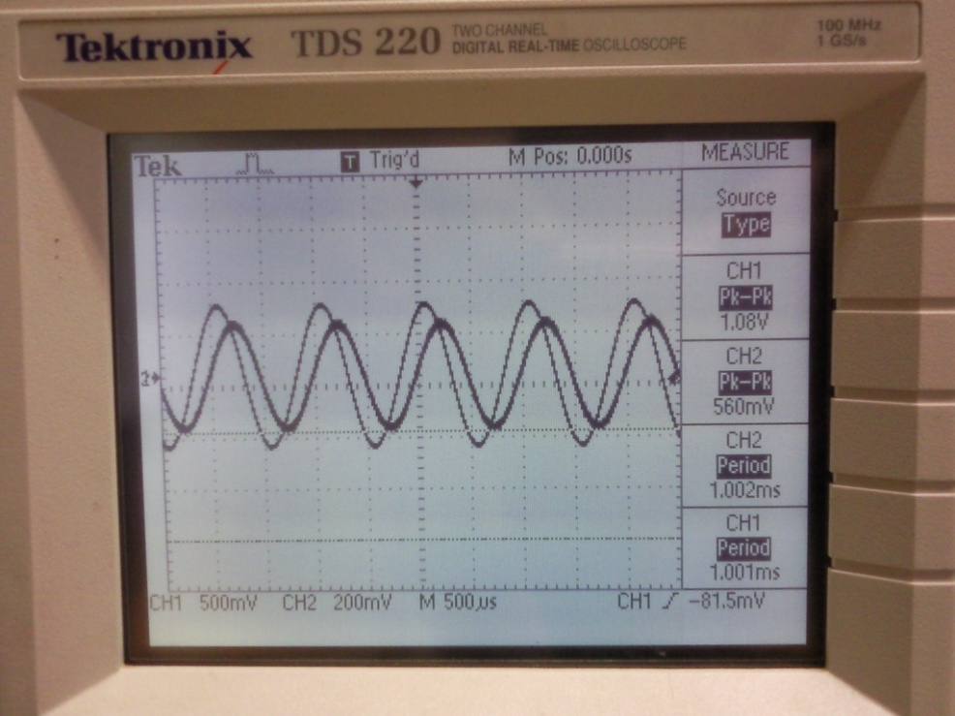

For f = 100 Hz, we obtained 2 distinct graphs of Vout andVin as shown in the figure. We can notice that Vout clearly lags Vin in this case.

The value of Vout as read on the oscilloscope is = 78 mV

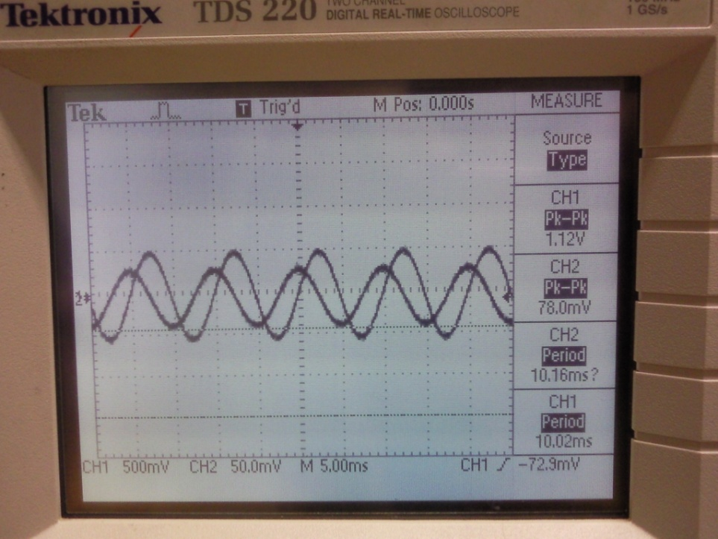

* Square wave:

For f = 10 kHz, we obtained 2 overlapping graphs of Vout andVin as shown in the figure.

The value of Vout as read on the oscilloscope is = 1300 mV.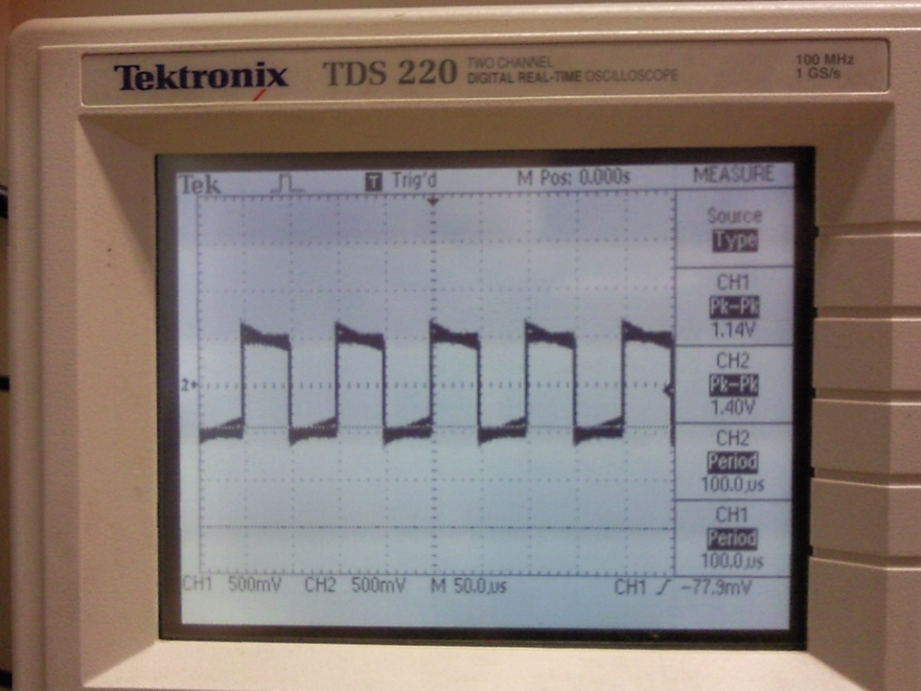

For f = 1 kHz, we obtained 2 distinct graphs of Vout andVin as shown in the figure. We can notice the difference between the 2 graphs. The shape of the output differs from the input. This is due to the fact that the circuit is a high pass filter and it is removing the low harmonics of the square wave (Fourier). Therefore we have distortion.

The value of Vout as read on the oscilloscope is = 2000 mV

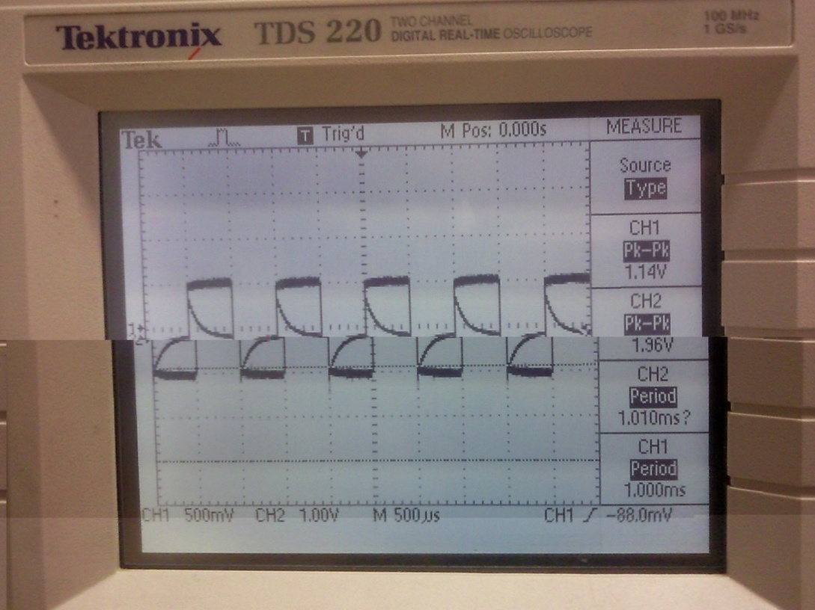

For f =100 Hz, we obtained 2 distinct graphs of Vout andVin as shown in the figure. At this frequency, which is considered low, the output appeared as steps and impulses. This is because, when we have low frequencies, RC circuit acts as a differentiator.

The value of Vout as read on the oscilloscope is 2000mV

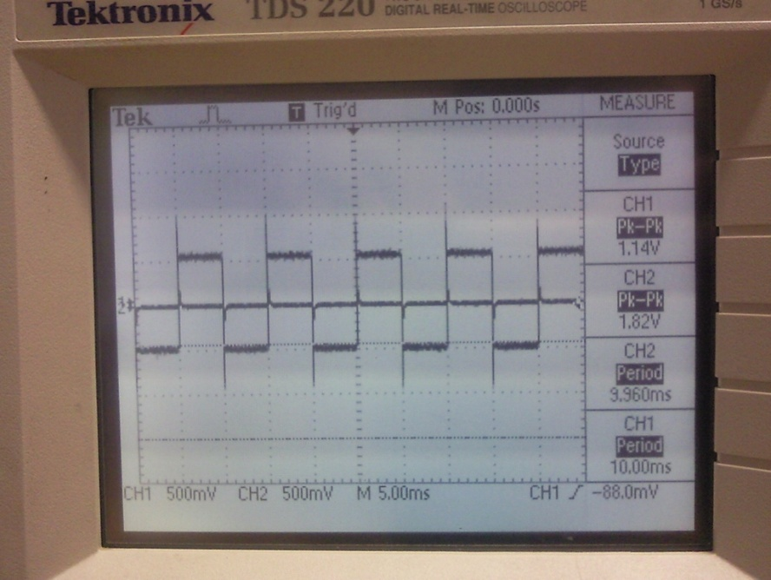

**Comparison and % of error:**

|  |  |  |  |
| --- | --- | --- | --- |
| Frequency | Theoretical value of Vout | Vout for Sine wave input | Vout for Square wave input |
| 10 kHz | 987.57 mV | 1000 mV | 1300 mV |
| 1 kHz | 532.02 mV | 552 mV | 2000 mV |
| 100 Hz | 62 mV | 78 mV | 2000 mV |

The values measured experimentally for a sine wave input were the closest to the theoretical values.

* Sinusoidal wave:

For f= 100 Hz, %error= 25.8%

For f= 1 kHz, % error= 3.62%

For f = 10 kHz, % error= 1.26%

* Square wave:

For f= 100 Hz, %error= 31.63%

For f= 1 kHz, % error= 275.9%

For f = 10 kHz, % error= 3125.8%

*B4. Discussions:*

**1.** lag network: At 100 Hz output is the same as the input.

It is known that at low frequencies, the capacitor has enough time to charge up to a voltage = Vsource. As we increase the frequency (period decreases), we notice that the capacitor does not have sufficient time to charge completely so it takes the shape seen in the figures.

**2**. time constant =RC, cut off frequency=1/RC =1/time constant

•f << cutoff frequency => f<< 1/RC

• The lag network acts as an integrator at very high frequencies: f> cut off frequency

• f>> cutoff frequency => f>>1/RC

•The lead-network acts as a differentiator very low frequencies: f<1/RC

**3.**

•f<<1/RC

•f>> 1/RC

Based on the Fourier theorem, a square wave is the sum of sinusoidal waves. Therefore these relations remain true for a square wave or a sine wave.

**4**.A lowpass filter blocks the high frequencies and allow low frequency to pass. While

a highpass filter blocks low frequencies and allow high frequencies to pass. The cutoff frequency of both filters is the same and it is equal to 1/RC in an RC circuit.

**5**. In an RC circuit, if we choose the output to be across C we will get a lag network and an integrator circuit. Whereas if we choose the output to be across R we will get a lead network and a differentiator circuit.

**6.** from KVL across a simple RC circuit : Vin = Vc + VR

When Vc charges completely, Vc= Vin and VR=0

When Vc discharges completely, Vc= 0and VR= Vin

1. ***Series RLC circuits***

*C1. Circuit diagram:*



*C2. Detailed experimental procedure:*

**Measurements settings:**

For the RLC circuit, we need to connect a resistor, capacitor and inductor. We provide a signal of 1 V peak to peak. We select a channel of the oscilloscope and connect it to the output which is across the resistor. The other one is connected to the input signal.

In this part of the experiment we were asked to use several resistors, capacitors and inductors of different values and observe the changes in each case. The frequency also does not take a fixed value.

**Assumptions:**

Wires have internal resistances. This fact is not taken into consideration during the theoretical computations.

*C3. Measurements and results:*

**Theoretical calculations:**

The Resonant frequency of an RLC circuit is:

ωo= 1/ (2π√LC) (in Hz) or *ω*0 =  (in radians/ sec)

The bandwidth of an RLC circuit is:

BW= R/(2πL) (in Hz) or BW=R/L (in radians/ sec)

For R=100 Ω, L= 220 uH, C=1uF, ωo= 1/ (2π√220*10-6*1*10-6)= 10.73 kHz

BW= 100/(2π*220*10-6)=72.343 kHz

For R=56 Ω, L= 220 uH, C=1uF, ωo= 1/ (2π√220*10-6*1*10-6)= 10.73 kHz

BW= 56/(2π*220*10-6)=40.512 kHz

Similarly, for R= 100 Ω, L= 470 uH, C=0.1uF, ωo =23.215 kHz

BW= 33.862 kHz

**Experimental results:**

* Set 1:

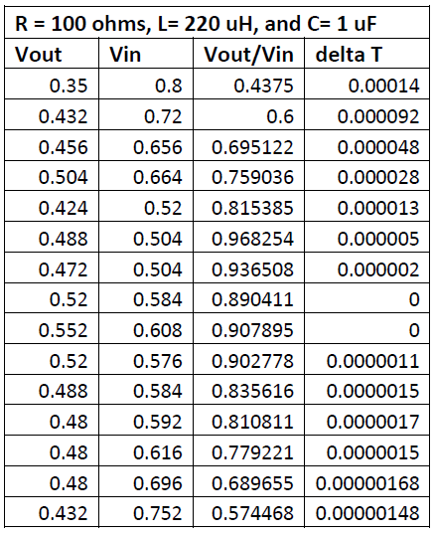

* Set 2:

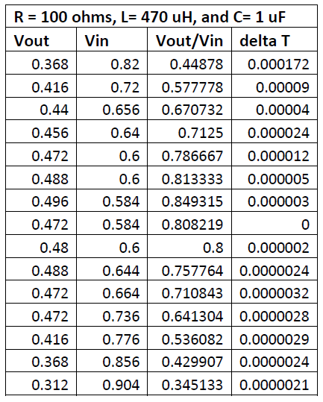

* Set 3:

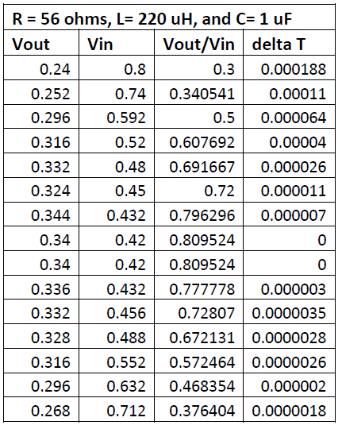

*C4. Discussions:*

**1.** For an RLC circuit, where the output is taken across R, the transfer function is:

$$\left|\frac{V_{R}}{V_{in}}\right|=\frac{R}{\sqrt{R^{2}+{\left(ωL-\frac{1}{wC}\right)}^{2}}}$$

**2.** for set 1:

|  |  |
| --- | --- |
| Frequency (Hz) | |Vout/Vin| |
| 1000 | 0.529 |
| 1400 | 0.654 |
| 2000 | 0.772 |
| 2800 | 0.855 |
| 4000 | 0.91 |
| 5400 | 0.938 |
| 7500 | 0.953 |
| 10000 | 0.959 |
| 14000 | 0.956 |
| 20000 | 0.942 |
| 28000 | 0.914 |
| 40000 | 0.86 |
| 54000 | 0.79 |
| 75000 | 0.687 |
| 100000 | 0.582 |

For set 2:

|  |  |
| --- | --- |
| Frequency (Hz) | |Vout/Vin| |
| 1000 | 0.525 |
| 1400 | 0.647 |
| 2000 | 0.76 |
| 2800 | 0.838 |
| 4000 | 0.889 |
| 5400 | 0.91 |
| 7500 | 0.917 |
| 10000 | 0.91 |
| 14000 | 0.885 |
| 20000 | 0.83 |
| 28000 | 0.749 |
| 40000 | 0.634 |
| 54000 | 0.524 |
| 75000 | 0.408 |
| 100000 | 0.319 |

For set 3:

|  |  |
| --- | --- |
| Frequency (Hz) | |Vout/Vin| |
| 1000 | 0.329 |
| 1400 | 0.436 |
| 2000 | 0.562 |
| 2800 | 0.678 |
| 4000 | 0.777 |
| 5400 | 0.835 |
| 7500 | 0.87 |
| 10000 | 0.883 |
| 14000 | 0.877 |
| 20000 | 0.844 |
| 28000 | 0.784 |
| 40000 | 0.687 |
| 54000 | 0.585 |
| 75000 | 0.468 |
| 100000 | 0.372 |

**3.** graph of set1:

Graph of set 2:

Graph of set 3:

**4.** As seen from the plots, the resonance frequency is the frequency where we graph arrives to a maximum.

Resonance frequency of set 1is: 10000 Hz

Bandwidth of set 1 is: 75000 Hz

Resonance frequency of set 2 is: 7500 Hz

Bandwidth of set 2 is: 35000 Hz

Resonance frequency of set 3 is: 10000 Hz

Bandwidth of set 3 is: 45000Hz

**5.** Theoretical values:

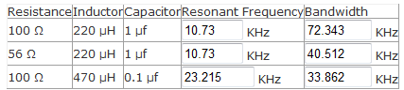

We can see the experimental values in question 4

We notice the difference between the 2. This is due to the experiments’ errors such as resistance in the wires, errors in the values of components, misreading from the plots.

**6.** We know that BW=R/2πL. Therefore the bandwidth and R are proportional. When R increases, BW increases, when R decreases BW decreases. The opposite is also correct.

**7.** We know from the formula of the bandwidth that BW and L are inversely proportional.

The bandwidth is independent of C. therefore its value is not affected by any changes in C.

**8.** as seen in the table of question 5:

The resonant frequency of set 2 is the highest (23.215 kHz).

Set 1 and set 3 have same resonant frequency (10.73) because they have same R and L.

The bandwidth of set 1 is the largest. While the bandwidth of set 2 is the narrowest (biggest value of L)

**References:**

<http://en.wikipedia.org/wiki/Lissajous_curve>

<http://www.google.com.lb/imgres?imgurl=http://static.intellego.fr/uploads/1/5/15435/media/oscilloscope/mesure%2520periode%25202.JPG&imgrefurl=http://www.intellego.fr/soutien-scolaire--/aide-scolaire-physique/fonctionnement-de-l-oscilloscope-mesure-d-une-periode/11958&usg=__eqs0fxXB8VckiYFzS0ZfHlgcwTE=&h=343&w=428&sz=17&hl=en&start=6&zoom=1&tbnid=iw2xii65EXQESM:&tbnh=101&tbnw=126&ei=lfy2Tu6tF86VOqTPmYYC&prev=/search%3Fq%3Dmesure%2Bde%2Bperiode%2BT%2Bsur%2Boscilloscope%26um%3D1%26hl%3Den%26sa%3DN%26biw%3D1366%26bih%3D534%26tbm%3Disch&um=1&itbs=1>

<http://www.physique-appliquee.net/physique/sinus/sinus_cours/regsinus.html>

<http://www.yourformulasheet.com/index.php?/percent-error-formula.html>

Sabah, N (2008). *Electric circuits and signals*. Florida: CRC press. 361-375

**Mistakes and problems faced in the lab:**

We were not faced by any major problem or obstacle during this lab. We only made a calculation mistake in computing the magnitude of the transfer function in the lag network. But we soon fixed it and continued our work.

*“I HAVE NEITHER GIVEN NOR RECEIVED AID ON THIS REPORT NOR HAVE I CONCEALED ANY VIOLATION OF THE AUB STUDENT CODE OF CONDUCT.”*

C:\Users\user\Desktop\Emilie.jpg

Emilie Y. Akiki